User Guide 54 SPEAR Reporting
Purpose of this User Guide
The purpose of this User Guide is to provide information on how to access and use the SPEAR Reporting functions available within SPEAR, including running reports and extracting data to Microsoft Office applications such as Excel or PowerPoint. The ability to run reports from SPEAR is restricted to Local Administrator users within your organisation by default, however Local Administrators can enable all users within their organisation to access and run reports if they choose.
Who should read this guide?
Primary audience: Local Administrators
For information: Other SPEAR users
Introduction
A range of reports are available to users in SPEAR, however the specific reports available to each organisation type will vary. A full list of reports available to your organisation can be accessed from the Admin Reports menu.
54.1 How do Local Administrators access SPEAR Reporting?
Users in SPEAR may have multiple roles. Stand-alone Administrators will see the Administration Menu when they login to SPEAR.
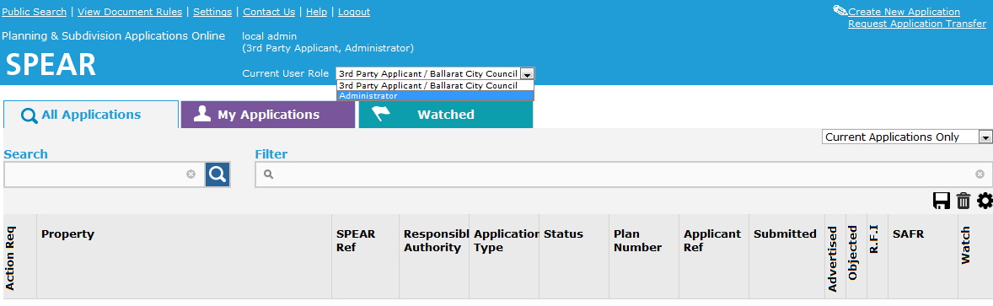
Users with additional roles can access the Administration Menu by changing their Current User Role to Administrator from the drop-down box located on the Application List screen.

To open the Admin Reports menu, click the SPEAR Reporting hyperlink from the Administration Menu. You will be provided with a list of available reports.
54.2 How do all other users access SPEAR Reporting?
By default, SPEAR reports are only available to Local Administrators within an organisation. Local Administrators can choose to enable SPEAR Reporting for all other users in their organisation.
For more information about enabling SPEAR Reporting for all users in your organisation, see User Guide 23 – Local Administrator.
If the Local Administrator for your organisation has enabled SPEAR reporting for all users, you will be able to access the reports via the menu at the top of the SPEAR screen.
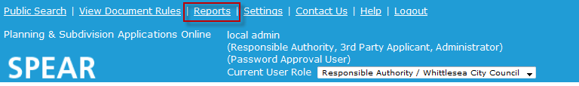

54.3 How do I run a report?
Click on the name of the required report from the Admin Reports menu. The Parameter window will open in a new browser tab or window.
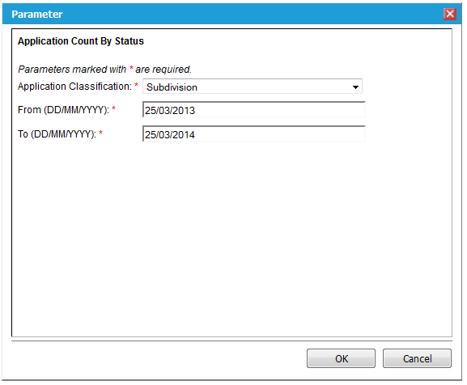
Depending on the report you have selected, you will be provided with a range of parameters which will affect the data displayed in the report. Select or enter the parameters as required and click ‘OK’ to run and display the report.

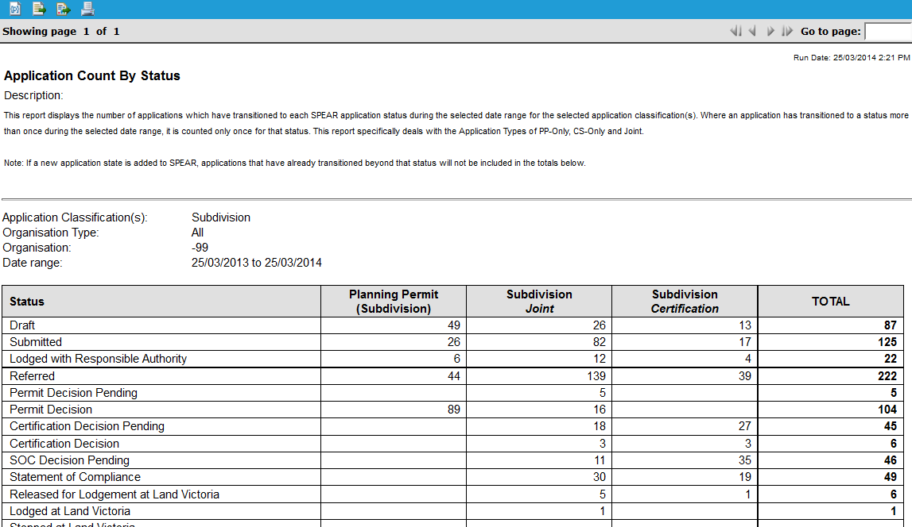

The report may span several pages. To navigate to a different page, you can use the grey arrows displayed at the top-right of the report. Alternatively, you can enter the page number you wish to view and click the green arrow to navigate to that page.
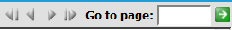
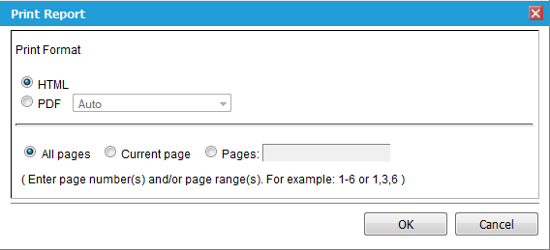
Once run, the report can be printed by clicking on the icon at the top-left of the report screen. The Print Report window is displayed and will allow you to specify the format and pages you wish to print. Once you click ‘OK’ , the printable report will open in a new browser tab or window.

54.4 How can I modify the data shown in a report?
If you would like to run the report with different parameters, click on the icon at the top-left of the report. You will be presented with the Parameter window and can make changes as required before clicking ‘OK’ to run the report.
54.5 How do I export the report data?
The report can be exported to various file formats including Excel (.xls), PowerPoint (.ppt) and Portable Document Format (.pdf).
To export the report data, you will need to run the required report and click the icon at the top-left of the report. You will be presented with the Export Report window, where you can specify the format, you wish the report to be exported to. You can also choose the pages you wish to export and the size of these pages before clicking ‘OK’ to download the exported report file in the format you have chosen.
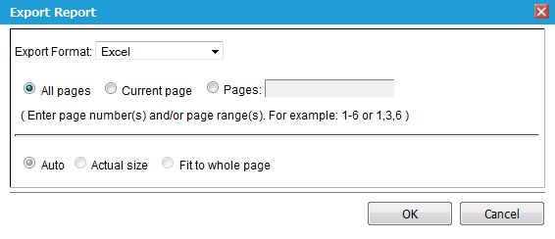

Need more information?
Further information on this topic can be found by:
- Visiting the SPEAR website www.spear.land.vic.gov.au/SPEAR
- Contacting the SPEAR Service Desk on (03) 9194 0612 or email spear.info@delwp.vic.gov.au

